VIDYA JYOTHI INSTITUTE OF TECHNOLOGY
AN AUTONOMOUS INSTITUTION
(Accredited by NAAC A+ Approved by AICTE New Delhi & Permanently Affiliated to JNTUH)
Aziz Nagar Gate, C.B. Post, Hyderabad-500 075

DEPARTMENT OF INFORMATION TECHNOLOGY
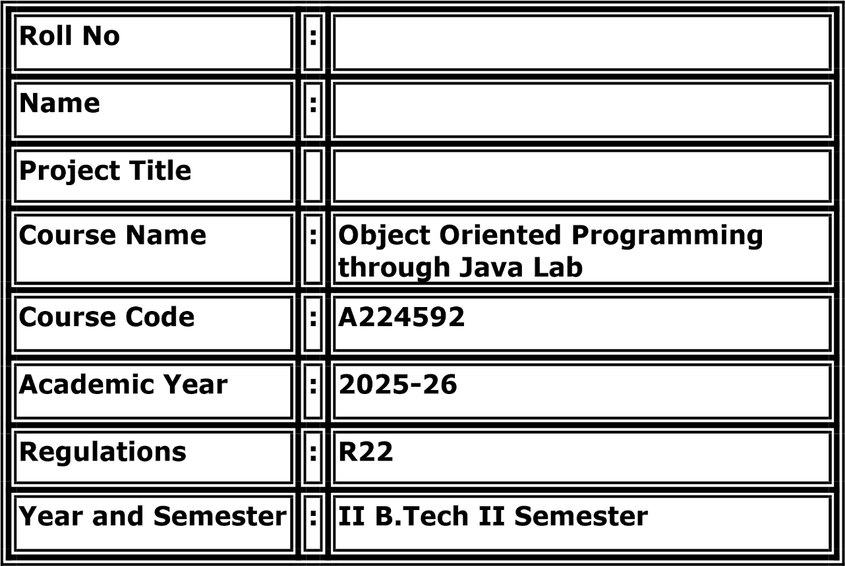
Chat Application
M.Shreya
24911A12A0



CERTIFICATE

This is to certify that the Object Oriented Programming through Java Lab project report entitled “ Chat Application ” submitted by 24911A12A0 to Vidya Jyothi Institute of Technology (An Autonomous Institution), Hyderabad, of B. Tech. II year, II Semester in Information Technology a Bonafide record of Lab project work carried out by them under my supervision.

Signature of Faculty | Signature of Head of the Department
Mr. B Eswar Babu | Dr. A. Obulesu
Associate Professor | Professor

Abstract
The Chat Application is a Java-based real-time messaging system developed to enable users to communicate instantly over a network. In traditional communication systems, establishing reliable, multi-user chat functionality manually can be complex and error-prone. The need for a scalable and efficient system that can handle multiple concurrent connections forms the basis of this project.
The main objective of this project is to provide a reliable messaging platform that allows users to connect to a server, send and receive messages in real time, and maintain communication sessions. The system also ensures data integrity and smooth message delivery during concurrent user connections through synchronization and socket programming techniques.
The project is developed using Java as the programming language and utilizes Java Socket Programming and Multithreading for managing client-server communication. Core Java concepts such as ServerSocket, Socket, BufferedReader, PrintWriter, multithreading, synchronization, exception handling, and object-oriented programming are implemented to enhance the functionality and reliability of the system. The GUI is developed using Java Swing to provide a user-friendly interface.
The expected outcome of the project is a user-friendly chat application capable of efficiently managing multiple user sessions and real-time message exchange. It ensures accurate delivery of messages, prevents data inconsistencies during simultaneous connections, and provides a secure and smooth communication experience. The system demonstrates the practical application of advanced Java concepts and serves as an effective learning tool for understanding socket-based networking and concurrent programming in real-world communication environments.

Table of Contents

Chapter No Title Page No
1 Introduction 4
- System Analysis 6
- System Design 9
- Implementation 11
- Testing 16
- Results 18
- Conclusion 20

Chapter 1 – Introduction
1.1 Project Overview
The Chat Application is a Java-based real-time messaging system designed to allow multiple users to connect to a central server and exchange messages simultaneously. The system provides a simple and efficient way to communicate over a network using socket programming and multithreading techniques.
In traditional communication systems, managing real-time messaging manually can be time-consuming and may lead to delays and data inconsistencies. This project eliminates such issues by providing a networked chat solution that handles multiple client connections accurately and efficiently using Java ServerSocket and Socket classes.
The project also demonstrates the use of multithreading to handle concurrent client connections, ensuring that messages from multiple users are processed and delivered without blocking. A graphical user interface built with Java Swing provides an intuitive experience for end users.
Real-World Applications
Instant messaging platforms
Online customer support systems
Team collaboration tools
Educational virtual classrooms
Game communication systems

1.2 Objectives
The main objectives of the Chat Application are:
To build a real-time multi-user chat system using Java socket programming.
To handle multiple client connections simultaneously using multithreading.
To deliver messages accurately and efficiently across the network.
To maintain chat session history for users during a session.
To ensure safe message broadcasting through synchronized methods.
To demonstrate the implementation of Java networking concepts in a practical application.
To provide a clean and intuitive Swing-based GUI for user interaction.

1.3 Scope of the Project
The Chat Application is intended for use by multiple users who wish to communicate over a local area network or the internet. The system allows users to connect to a server, send and receive messages in real time, and view ongoing conversations.
The project can be further enhanced in the future by adding advanced features such as:
User authentication and login system
Private messaging between specific users
File and image sharing capabilities
Message encryption for secure communication
Persistent chat history using database storage
Mobile application support
Group chat rooms and channel management
The system is scalable and can be expanded to support larger user bases, advanced communication protocols, and additional messaging functionalities as required.

Chapter 2 – System Analysis

2.1 Functional Requirements
The Chat Application must provide the following functionalities:
User Connection Management
- Allow multiple clients to connect to the chat server.
- Assign unique usernames to each connected client.
Send Messages
- Allow users to type and send messages to all connected clients.
- Broadcast messages to all active users in real time.
Receive Messages
- Display incoming messages from other users instantly.
- Show sender username along with each message.
User Join/Leave Notification
- Notify all users when a new client joins the chat.
- Notify all users when a client disconnects.
Chat History
- Display all messages exchanged during the current session.
- Scroll through previous messages within the chat window.
Server Management
- Start and stop the server as required.
- Manage all connected client threads centrally.
Concurrent Connection Handling
- Support multiple simultaneous users using multithreading.
- Ensure safe message delivery through synchronization.

2.2 Non-Functional Requirements
Security
- Protect message data from unauthorized interception.
- Validate user inputs to prevent malicious data injection.
Performance
- Deliver messages with minimal latency.
- Support a large number of concurrent connections efficiently.
Reliability
- Maintain stable connections without message loss.
- Handle disconnections gracefully without crashing the server.
Scalability
- Support additional users and features in the future.
- Handle increasing network traffic without performance degradation.
Maintainability
- Follow modular programming practices for easy updates.
- Allow easy integration of new features.
Availability
- Ensure the server remains accessible to clients at all times.

2.3 Software Requirements

Requirement | Details
RAM | 4 GB or Above
Processor | Intel i3 or Above
Storage | 500 GB HDD / SSD
Monitor | Standard Display
Keyboard | Standard Keyboard
Mouse | Standard Mouse
Network | LAN / Internet Connection

The above hardware and software requirements are sufficient for developing, testing, and running the Chat Application efficiently.

2.4 Hardware Requirements
Requirement | Details
RAM | 4 GB or Above
Processor | Intel i3 or Above
Storage | 500 GB HDD / SSD
Monitor | Standard Display
Keyboard | Standard Keyboard
Mouse | Standard Mouse
Network | LAN / Internet Connection

Chapter 3 – System Design
3.1 Architecture Design
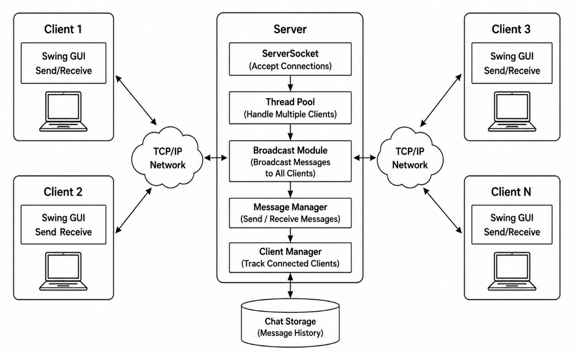
3.2 UML Diagrams

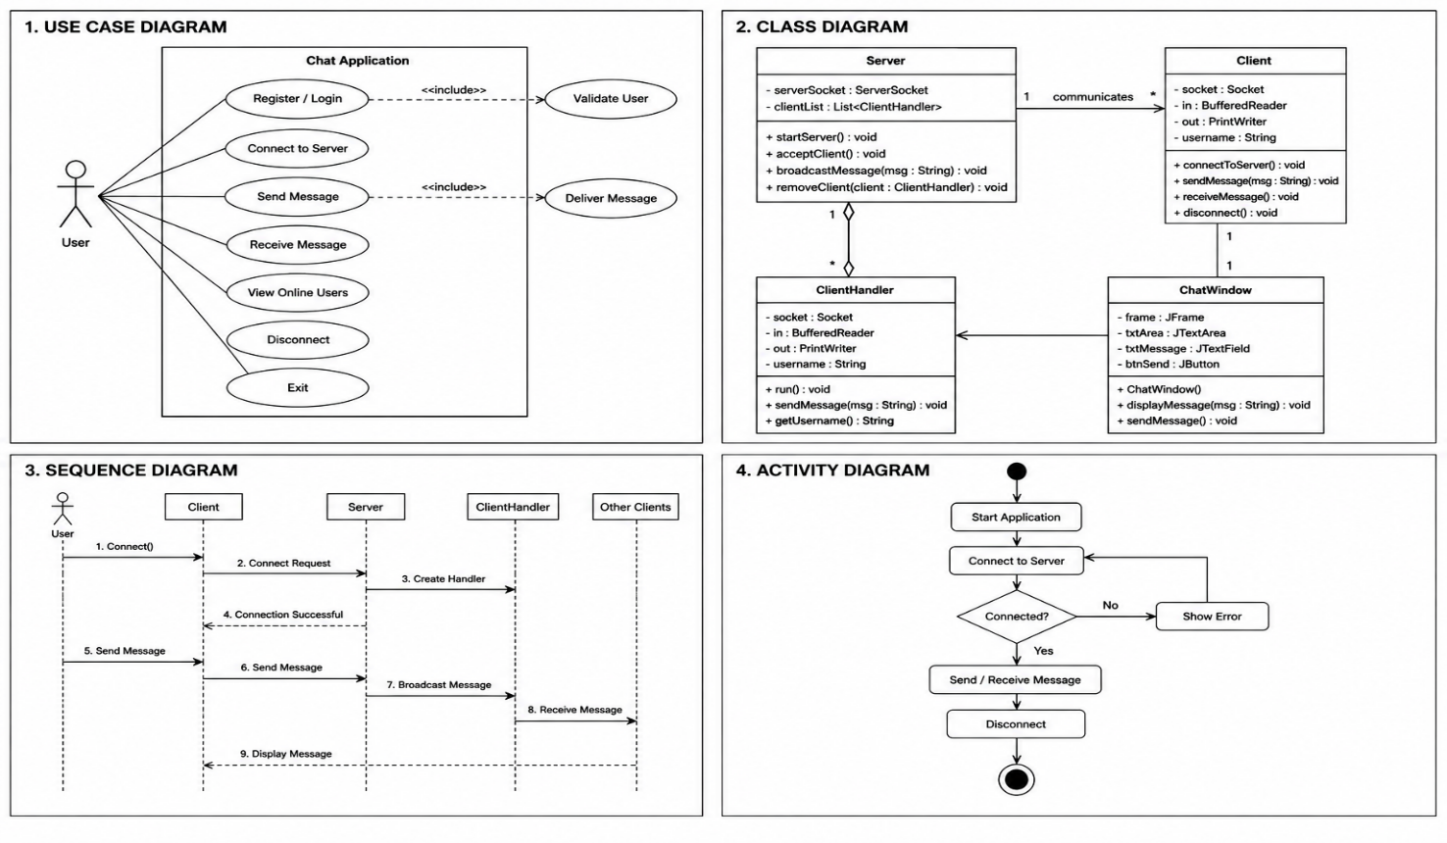

3.3 Database Design
The Chat Application primarily uses in-memory data structures for session management. However, for persistent storage, the following design is recommended:

Table 1: users
Field Name | Data Type | Description
user_id | INT | Unique user ID (Primary Key)
username | VARCHAR(50) | Username of the client
joined_at | TIMESTAMP | Time when user joined

Table 2: messages
Field Name | Data Type | Description
message_id | INT | Unique message ID (Primary Key)
user_id | INT | Sender's user ID (Foreign Key)
message_text | TEXT | Content of the message
sent_at | TIMESTAMP | Date and time of message

One user can send multiple messages. The user_id in the messages table references the user_id in the users table, maintaining the relationship between users and their messages.

Chapter 4 - Implementation

4.1 Modules Description
Module | Description
Server Module | Starts the server, listens for connections, and manages client threads.
Client Handler Module | Manages each connected client in a separate thread.
Client Module | Connects to the server and provides send/receive functionality.
GUI Module | Provides a Swing-based graphical interface for users.
Message Broadcast Module | Sends messages from one client to all connected clients.
Username Module | Assigns and validates usernames for each client.
Synchronization Module | Ensures thread-safe access to the shared clients list.
Exception Handling Module | Handles connection failures, IO errors, and invalid input.

4.2 Important Java Concepts Used
1. Classes and Objects
Classes such as ChatServer, ChatClient, ClientHandler, and ChatGUI are defined as objects representing different components of the chat system.
2. Inheritance
The ClientHandler class extends Thread to enable concurrent execution for each connected client.
3. Polymorphism
Polymorphism allows the run() method to be overridden in ClientHandler, providing each client thread with its own message-handling behavior.
4. Exception Handling
Exception handling is used to manage runtime errors such as connection failures, socket timeouts, invalid inputs, and IO exceptions during message transmission.
5. Multithreading
Multithreading enables multiple client connections to be handled simultaneously. Each connected client is assigned a dedicated ClientHandler thread.
6. Synchronization
Synchronization ensures that the shared list of connected clients is accessed and modified safely by multiple threads, preventing race conditions.
7. Collections
Java Collections (ArrayList or CopyOnWriteArrayList) are used to store and manage all connected client handlers efficiently.
8. Socket Programming
Java's ServerSocket and Socket classes are used to establish and manage TCP connections between the server and multiple clients.
9. AWT/Swing
Java Swing is used to build the graphical user interface including JFrame, JTextArea, JTextField, and JButton components.
10. I/O Streams
BufferedReader and PrintWriter are used to read and write text data over socket streams for message communication.

4.3 Code Snippets
Server Code (ChatServer.java)
import java.net.*;
import java.io.*;
import java.util.*;

public class ChatServer {
private static final int PORT = 12345;
private static List<ClientHandler> clients =
Collections.synchronizedList(new ArrayList<>());

public static void main(String[] args) throws IOException {
ServerSocket serverSocket = new ServerSocket(PORT);
System.out.println("Server started on port " + PORT);
while (true) {
Socket socket = serverSocket.accept();
ClientHandler handler = new ClientHandler(socket, clients);
clients.add(handler);
new Thread(handler).start();
}
}

public static void broadcast(String message, ClientHandler sender) {
for (ClientHandler client : clients) {
if (client != sender) {
client.sendMessage(message);
}
}
}
}

ClientHandler Code
class ClientHandler implements Runnable {
private Socket socket;
private String username;
private PrintWriter out;
private List<ClientHandler> clients;

public ClientHandler(Socket socket, List<ClientHandler> clients) {
this.socket = socket;
this.clients = clients;
}

public void run() {
try {
BufferedReader in = new BufferedReader(
new InputStreamReader(socket.getInputStream()));
out = new PrintWriter(socket.getOutputStream(), true);
username = in.readLine();
String message;
while ((message = in.readLine()) != null) {
ChatServer.broadcast(username + ": " + message, this);
}
} catch (IOException e) {
System.out.println(username + " disconnected.");
} finally {
clients.remove(this);
}
}

public void sendMessage(String message) {
out.println(message);
}
}

Client Code (ChatClient.java)
import java.net.*;
import java.io.*;

public class ChatClient {
public static void main(String[] args) throws IOException {
Socket socket = new Socket("localhost", 12345);
BufferedReader in = new BufferedReader(
new InputStreamReader(socket.getInputStream()));
PrintWriter out = new PrintWriter(socket.getOutputStream(), true);
BufferedReader console = new BufferedReader(
new InputStreamReader(System.in));
System.out.print("Enter username: ");
String username = console.readLine();
out.println(username);
new Thread(() -> {
try {
String msg;
while ((msg = in.readLine()) != null) {
System.out.println(msg);
}
} catch (IOException e) { e.printStackTrace(); }
}).start();
String input;
while ((input = console.readLine()) != null) {
out.println(input);
}
}
}

Message Broadcast Method
public synchronized void broadcast(
String message, ClientHandler sender) {
for (ClientHandler client : clients) {
if (client != sender) {
client.sendMessage(message);
}
}
}

Swing GUI Snippet
JFrame frame = new JFrame("Chat Application");
JTextArea chatArea = new JTextArea(20, 40);
chatArea.setEditable(false);
JTextField inputField = new JTextField(30);
JButton sendButton = new JButton("Send");

sendButton.addActionListener(e -> {
String msg = inputField.getText();
out.println(msg);
chatArea.append("You: " + msg + "\n");
inputField.setText("");
});

frame.add(new JScrollPane(chatArea), BorderLayout.CENTER);
frame.add(inputField, BorderLayout.SOUTH);
frame.add(sendButton, BorderLayout.EAST);
frame.pack();
frame.setVisible(true);

The implementation successfully integrates socket programming, multithreading, synchronization, exception handling, and object-oriented programming concepts to develop a reliable Chat Application.

Chapter 5 – Testing
5.1 Test Cases
Test Case ID | Input | Expected Output | Result | Status
TC01 | Start Server | Server starts and listens on port 12345 | Server Running | Pass
TC02 | Client Connects | Client connected successfully, username assigned | Connected | Pass
TC03 | Send Message | Message delivered to all connected clients | Delivered | Pass
TC04 | Multiple Clients Send Simultaneously | All messages delivered without data loss | No Loss | Pass
TC05 | Client Disconnects | Server notifies all users; session ends cleanly | Notified | Pass
TC06 | Invalid Username (Empty) | Error message displayed to user | Error Shown | Pass
TC07 | Server Not Running – Client Connects | Connection refused error displayed | Error Shown | Pass
TC08 | Concurrent Connections | Data consistency maintained across all clients | Consistent | Pass

5.2 Error Handling
The Chat Application uses exception handling to ensure smooth execution and prevent system failures. The following exceptions are handled:
- ConnectException – Occurs when the client cannot connect to the server (server not started or wrong port).
- IOException – Occurs when there is an error reading from or writing to the socket stream.
- NullPointerException – Occurs when an object reference is null during message processing.
- SocketException – Occurs when a connection is unexpectedly closed or reset by the remote host.
- NumberFormatException – Occurs when an invalid port number is entered by the user.
- Exception – Used as a general exception handler for unexpected runtime errors.

Proper exception handling improves the reliability, stability, and user experience of the Chat Application.

Chapter 6 - Results and Screenshots
Figure 6.1: Server Start Screen
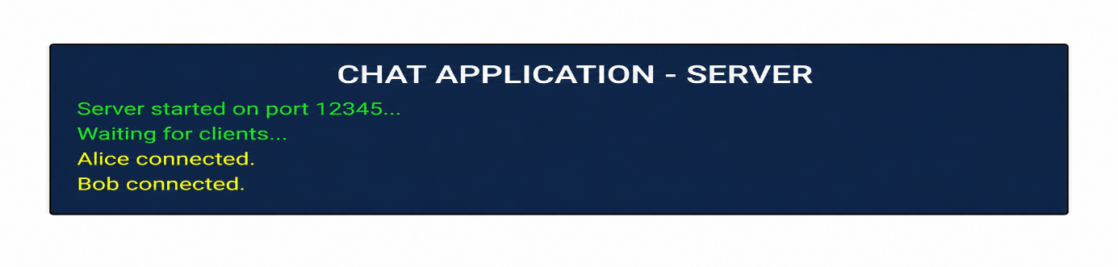Description: The server console shows successful startup on port 12345 and logs each client connection.
Figure 6.2: Client Chat Window (Swing GUI)
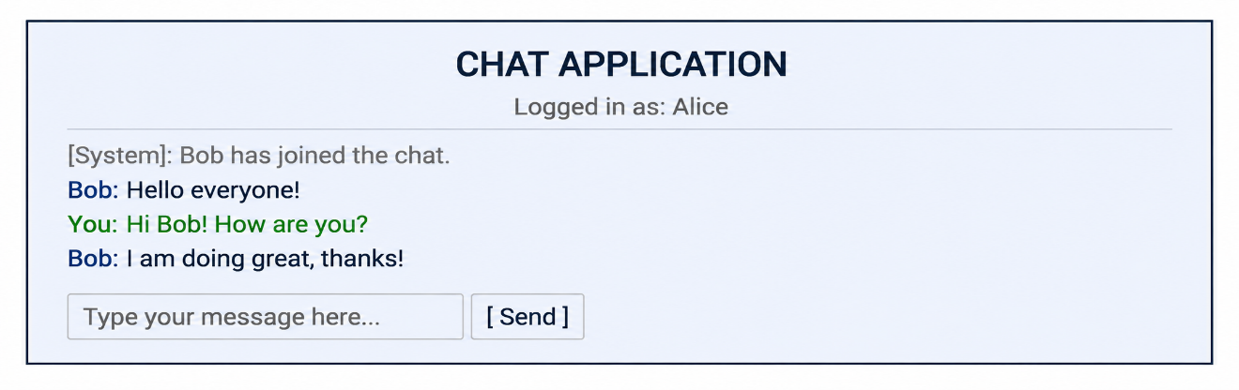Description: The Swing GUI chat window shows the chat area with messages from all users and an input field to type and send new messages.
Figure 6.3: Multiple Client Connections
Client: Alice  [System]: Bob joined.  Bob: Hello!  You: Hi Bob! | Client: Bob  [System]: You joined.  You: Hello!  Alice: Hi Bob!
Description: Two client windows running simultaneously, demonstrating real-time message synchronization between multiple users.

Chapter 7 – Conclusion and Future Scope
Conclusion
The Chat Application was successfully designed and implemented using Java socket programming, multithreading, and Java Swing for the GUI. The system provides essential real-time communication features such as multi-user messaging, user join/leave notifications, and concurrent connection handling. Synchronization was implemented to ensure safe access to the shared clients list, while exception handling improved the reliability and robustness of the application.
This project helped in understanding important Java concepts including Object-Oriented Programming, Multithreading, Synchronization, Socket Programming, Exception Handling, Collections, and Swing GUI development. The project successfully met its objectives by enabling real-time multi-user communication, handling concurrent connections safely, and providing an intuitive user interface.
Future Scope
The functionality of the Chat Application can be enhanced in the future through the following improvements:
- User Authentication and Login System for secure access control.
- Private Messaging between specific users for one-on-one conversations.
- File and Image Sharing capabilities within the chat.
- End-to-End Encryption for secure message transmission.
- Persistent Chat History using a MySQL database for storing messages.
- Cloud Deployment for remote server accessibility over the internet.
- Mobile Application Support for accessing the chat from smartphones.
- Group Chat Rooms and Channel Management for organized communication.
- SMS and Email Notifications for offline message alerts.
- Integration with REST APIs for connecting with external messaging services.

References
- Herbert Schildt, Java: The Complete Reference, Oracle Press, Latest Edition.
- Bruce Eckel, Thinking in Java, Prentice Hall.
- Oracle Java Documentation, Oracle Corporation.
- Java SE Development Kit (JDK) Documentation.
- Java Socket Programming Documentation, Oracle Corporation.
- Java Swing and AWT Documentation, Oracle Corporation.
- NetBeans IDE Documentation / Eclipse IDE Documentation.
- Java Multithreading and Concurrency Documentation, Oracle Corporation.

